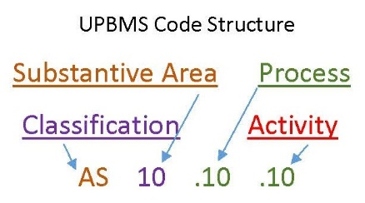
Support Branch Classifications

The Support Branch is used to describe processes associated with professional assistance provided to lawyers directly related to the delivery of legal services, advice and counsel.

Classifications represent the highest organizational level within each Branch of the ALA UPBMS Codes. They are used to organize the Substantive Areas into logical groupings. While they may generally follow departmental structures in some organizations, they are used more accurately to describe the nature of the activities detailed within each Substantive Area and Process.

Administrative Support (AS)

Processes associated with general office operations. Includes document services (production, reproduction and management), court services (docket), phone and fax services, meeting coordination, travel, facilities management, and mail/messenger services.

Substantive Areas within this Classification:

AS10 Document Services
AS15 Docket Services
AS20 Communication Services
AS25 Meetings Coordination
AS30 Travel Management
AS35 Facilities Management
AS40 Mail and Messenger Services

Finance (FN)

Processes associated with general accounting and financial operations, time entry, billing and collections, accounts payable, expense reports, analyzing money flows, and meeting all reporting, tax, and business operation requirements.

Substantive Areas within this Classification:

FN10 Credit and Collections
FN15 Financial Operations
FN20 Financial Planning
FN25 Tax and Compliance

Human Resources (HR)
Processes related to searching for and obtaining candidates, employee training and development, various forms of direct and indirect employee compensation, administration of the employer-employee relationship, employee communication, and managing and retaining valuable employees.

Substantive Areas within this Classification:

HR10 Recruitment and Selection
HR15 Compensation and Benefits
HR20 Employment Relationship Management
HR25 Training and Development
HR30 HR Consulting

Business Development (BD)

Processes aimed at developing and implementing growth opportunities, and communicating the value of a product, service or brand.

Substantive Areas within this Classification:

BD10 Product (Service) Development
BD15 Sales
BD20 Marketing

Information Technology (IT)

Processes and practices that gauge the end-to-end delivery of IT solutions and those used to manage the composite hardware, software, network resources and services comprising an enterprise IT environment.

Substantive Areas within this Classification:

IT10 IT Services
IT15 IT Infrastructure

Leadership and Management (LM)

Establishing and sharing a clear vision and the design, execution, and control of operations that convert resources into desired goods and services, develop the organization's strategy, and monitor operations to assure alignment with that strategy.

Substantive Areas within this Classification:

LM10 Organizational Management
LM15 Operational Management
LM20 Investor (Owner) Relations
LM25 Leadership Relations
LM30 Stakeholder Relations
LM35 Strategic Initiatives
LM40 Tactical Initiatives

Questions?

For further information about the ALA UPBMS or the public comment process, please contact: alaupbms@alanet.org.

