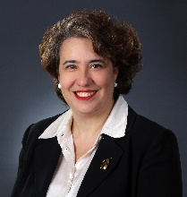  Angelina Angelov, CLM, MBA  Director  Russin Vecchi & Heredia Bonetti  Santo Domingo, DN  Dominican Republic  809-535-9511  aangelov@rvhb.com  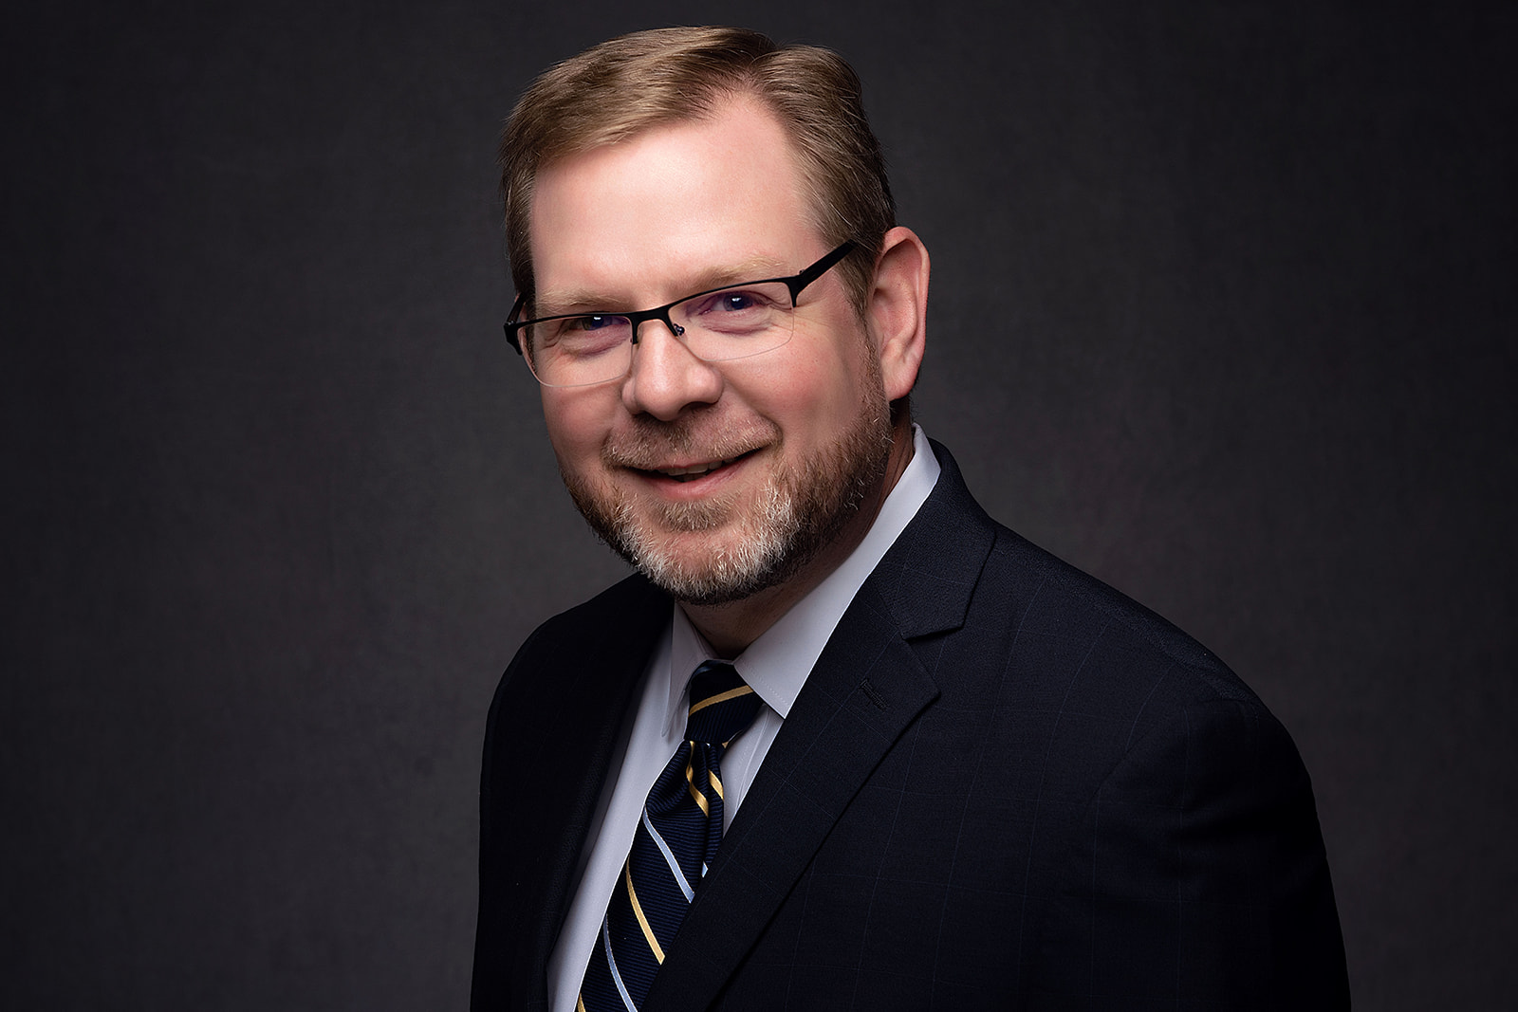  Travis C. Armstrong, CLM, CPA  President  English Lucas Priest & Owsley, LLP  Bowling Green, KY  270-781-6500  tarmstrong@elpolaw.com  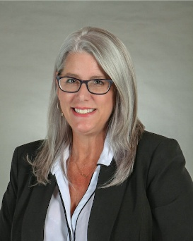  Elizabeth Bell  Independent Member Advisory Council Chair  DeFur Voran, LLP  Muncie, IN  (765) 288-3651  ebell@defur.com | 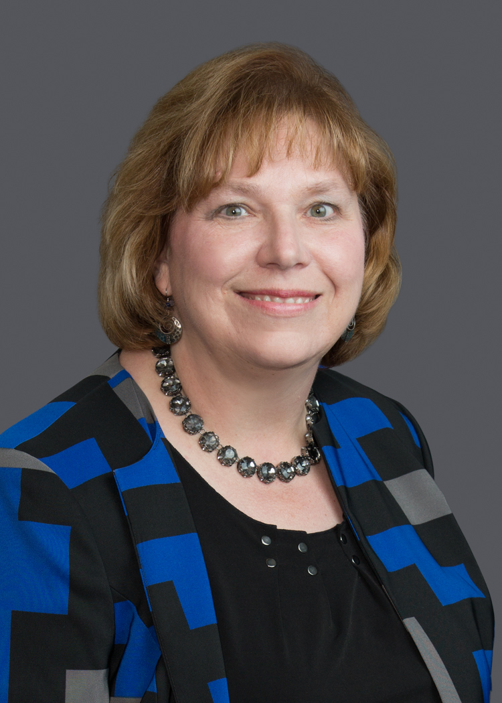  Dawn H. Anderson CLM, SPHR, JD, MBA  2026 Level Up: Legal Management Fundamentals Project Team Chair  Butler Snow LLP  Atlanta, GA  (678) 515-5407  dawn.anderson@butlersnow.com  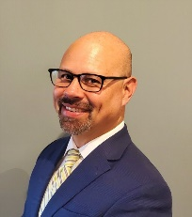  Daniel P. Atcheson  Director  Barnes & Thornburg LLP  Raleigh, North Carolina  252-229-7644  daniel.atcheson@btlaw.com  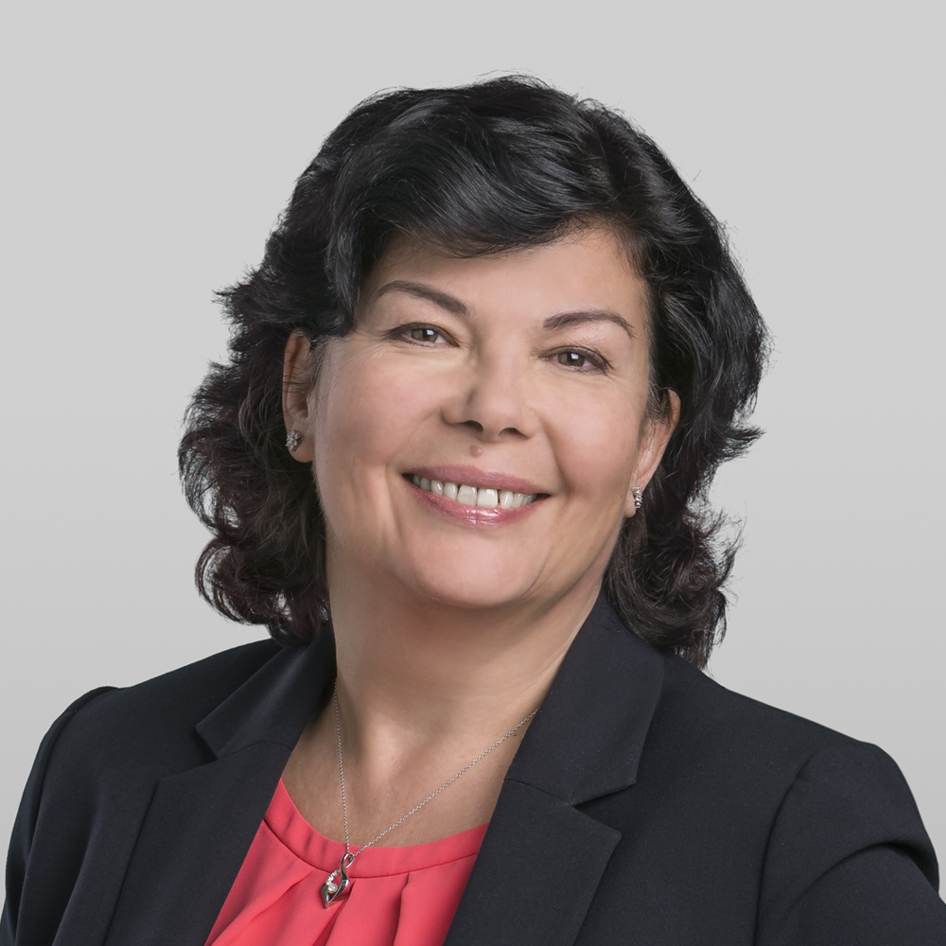  Diana Borova  Incoming Member Ambassador Committee Chair  McDonald Carano LLP  Reno, NV  (775) 326-4314  dborova@mcdonaldcarano.com
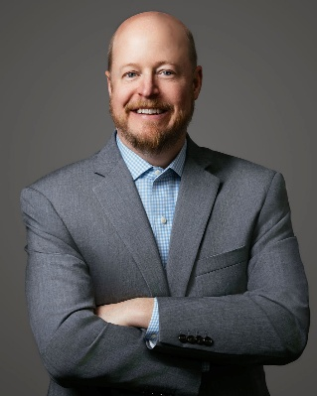  John D. Bowers  Future Readiness Advisory Council Chair  Thompson Burton PLLC  Nashville, TN  (615) 465-6000  john.bowers@thompsonburton.com | 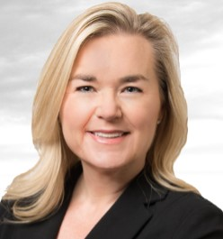  Katie J. Bryant, CLM – unable to attend  CLM Promotion Committee Chair  Udall Shumway PLC  Mesa, AZ  (480) 461-5345  kjb@udallshumway.com
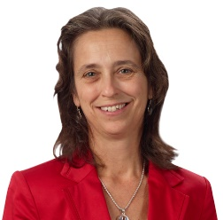  Linda Copson, CLM  Incoming CLM Certification Question Writing  Committee Chair  Downs Rachlin Martin, PLLC  St. Johnsbury, VT  802-473-4205  Lcopson@drm.com | 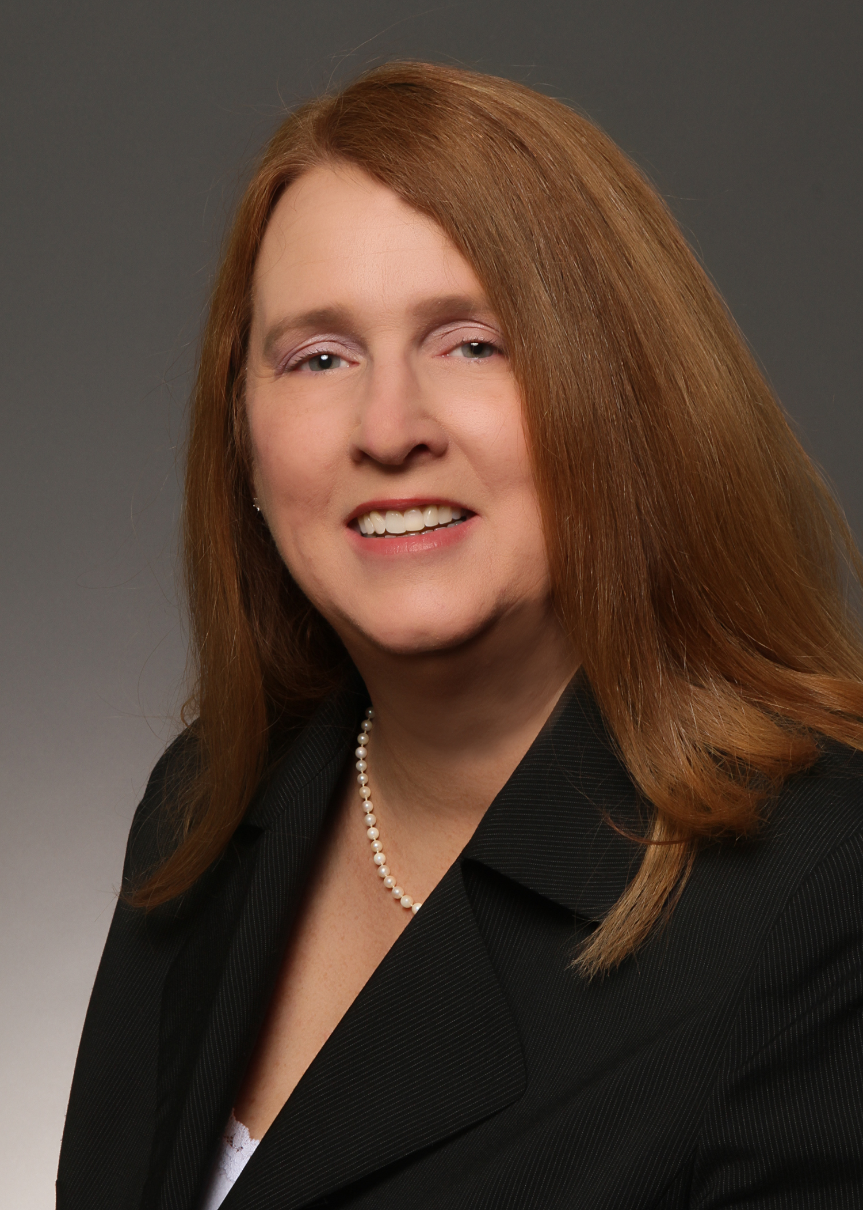  Lisa Dasher, CLM, CPA, CGMA  Incoming Volunteer Development and Experience Advisory Council Chair  Wicker Smith  Coral Gables, FL  (305) 448-3939 x8787  ldasher@wickersmith.com
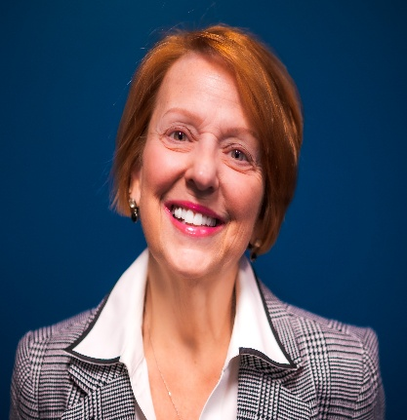  Brenda S. Deertz, MBA  Member Experience Committee Chair  Bi-State Development Agency  St. Louis, MO  314-982-1588  bsdeertz@bistatedev.org | 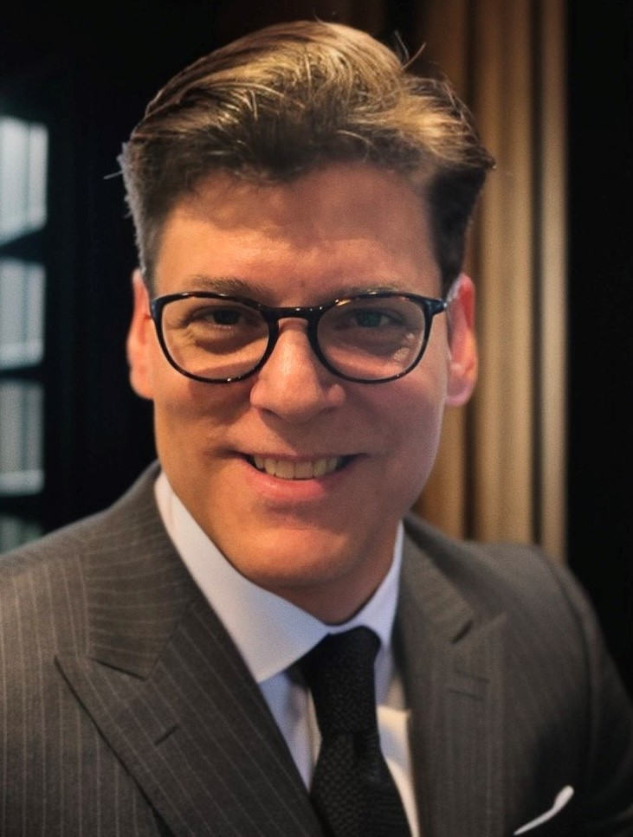  Frederick J. Esposito, CLM, MBA  Foundation of ALA Vice-President  Rivkin Radler LLP  Uniondale, NY  (516) 357-3330  fred.esposito@rivkin.com
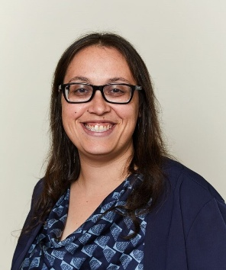  Elyssa A. Goldstein, CLM, PHR, SHRM-CP  President-Elect  Rebenack Aronow & Mascolo, LLP  New Brunswick, NJ  732-247-3600  egoldstein@ram.law | 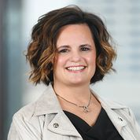  Brandi Hann  2026 LegaLeaders: Executive Leadership Summit Project Team Chair  Porter Wright Morris & Arthur LLP  Columbus, OH  (614) 227-2174  bhann@porterwright.com
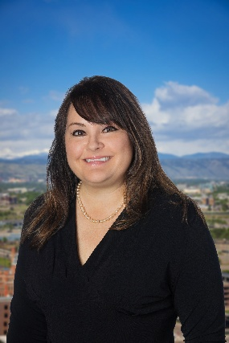  Stacie Hedrick, CLM  Chapter Connection Committee Chair, 2027 Annual Conference & Expo Project Team Chair  Welborn Sullivan Meck & Tooley, PC  Denver, CO  (303) 830-2500  shedrick@wsmtlaw.com | 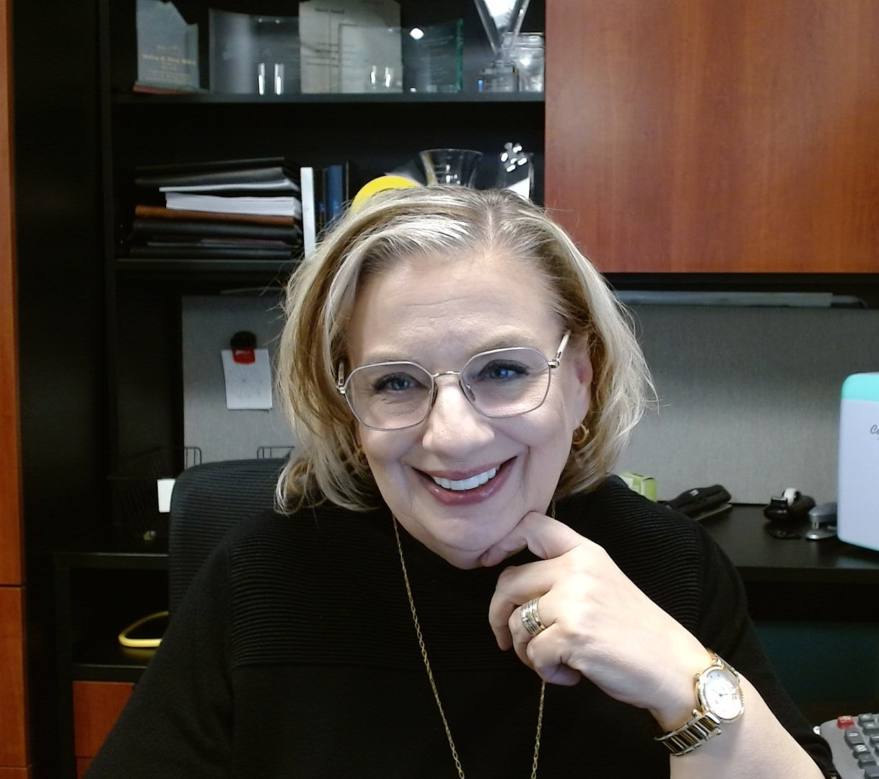  Melissa Hirst, MSLA  Director-Elect  Altitude Law  Lakewood, CO  (303) 991-2016  mhirst@altitude.law
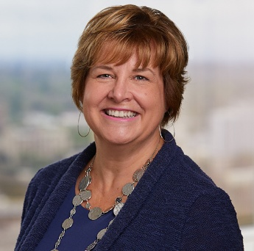  Lori A. Hughes  Member Ambassador Committee Chair  Miller Nash LLP  Portland, OR  (503) 205-2310  lori.hughes@millernash.com |   Rose A. Jaworecki  Director  Thompson Hine, LLP  New York, NY  212-908-3989  Rose.jaworecki@thompsonhine.com
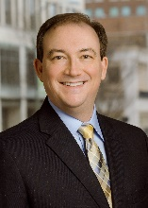 | 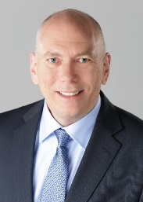
Michael E. Keatts  Incoming Chapter Connections Committee Chair  Bowman and Brooke LLP  Richmond, VA  804-819-1135  michael.keatts@bowmanandbrooke.com | Ken Koehn, CLM, CPA, CMA  Director  Gould & Ratner LLP  Chicago, IL  312-899-1620  Kkoehn@gouldratner.com
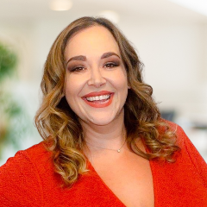  Amanda R. Koplos, CLM, CPA  Immediate Past President  Shuffield Lowman & Wilson, PA  Orlando, FL  (407) 581-9800  akoplos@shuffieldlowman.com | 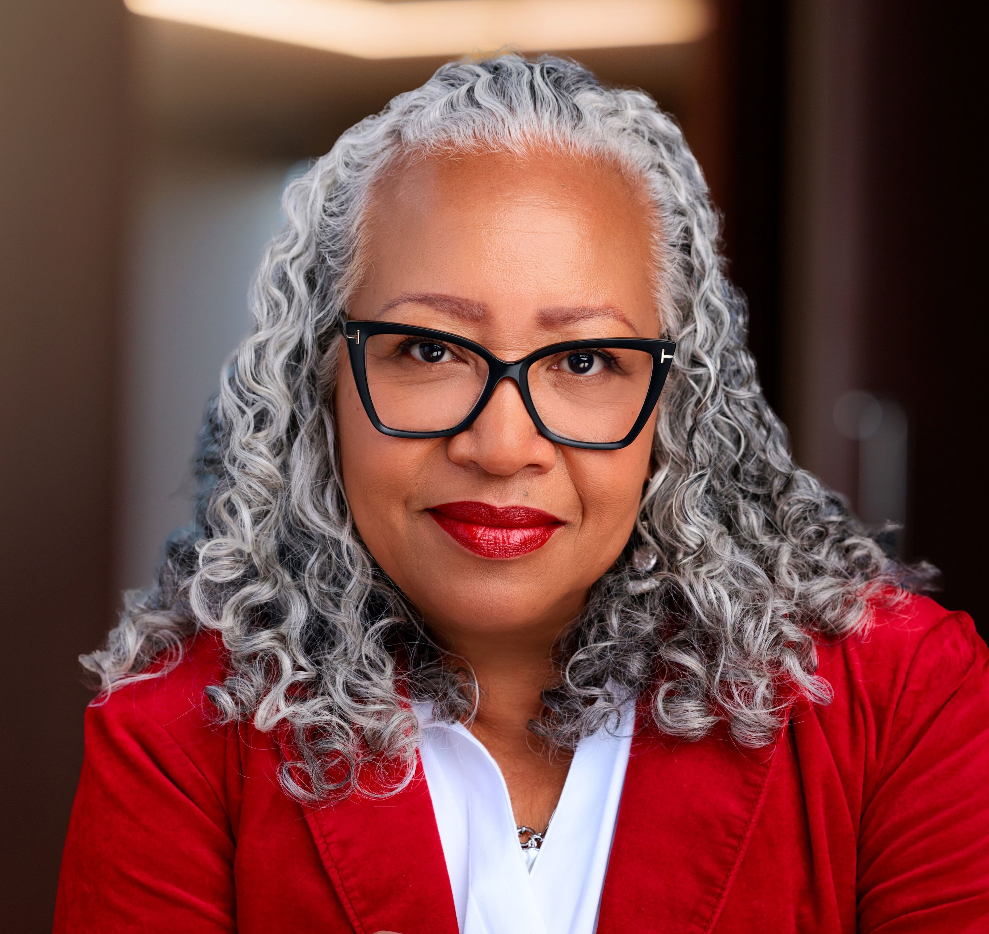  Shirley Laboy  Director-Elect  Bondurant Mixson & Elmore LLP  Atlanta, GA  (404) 881-4122  laboy@bmelaw.com
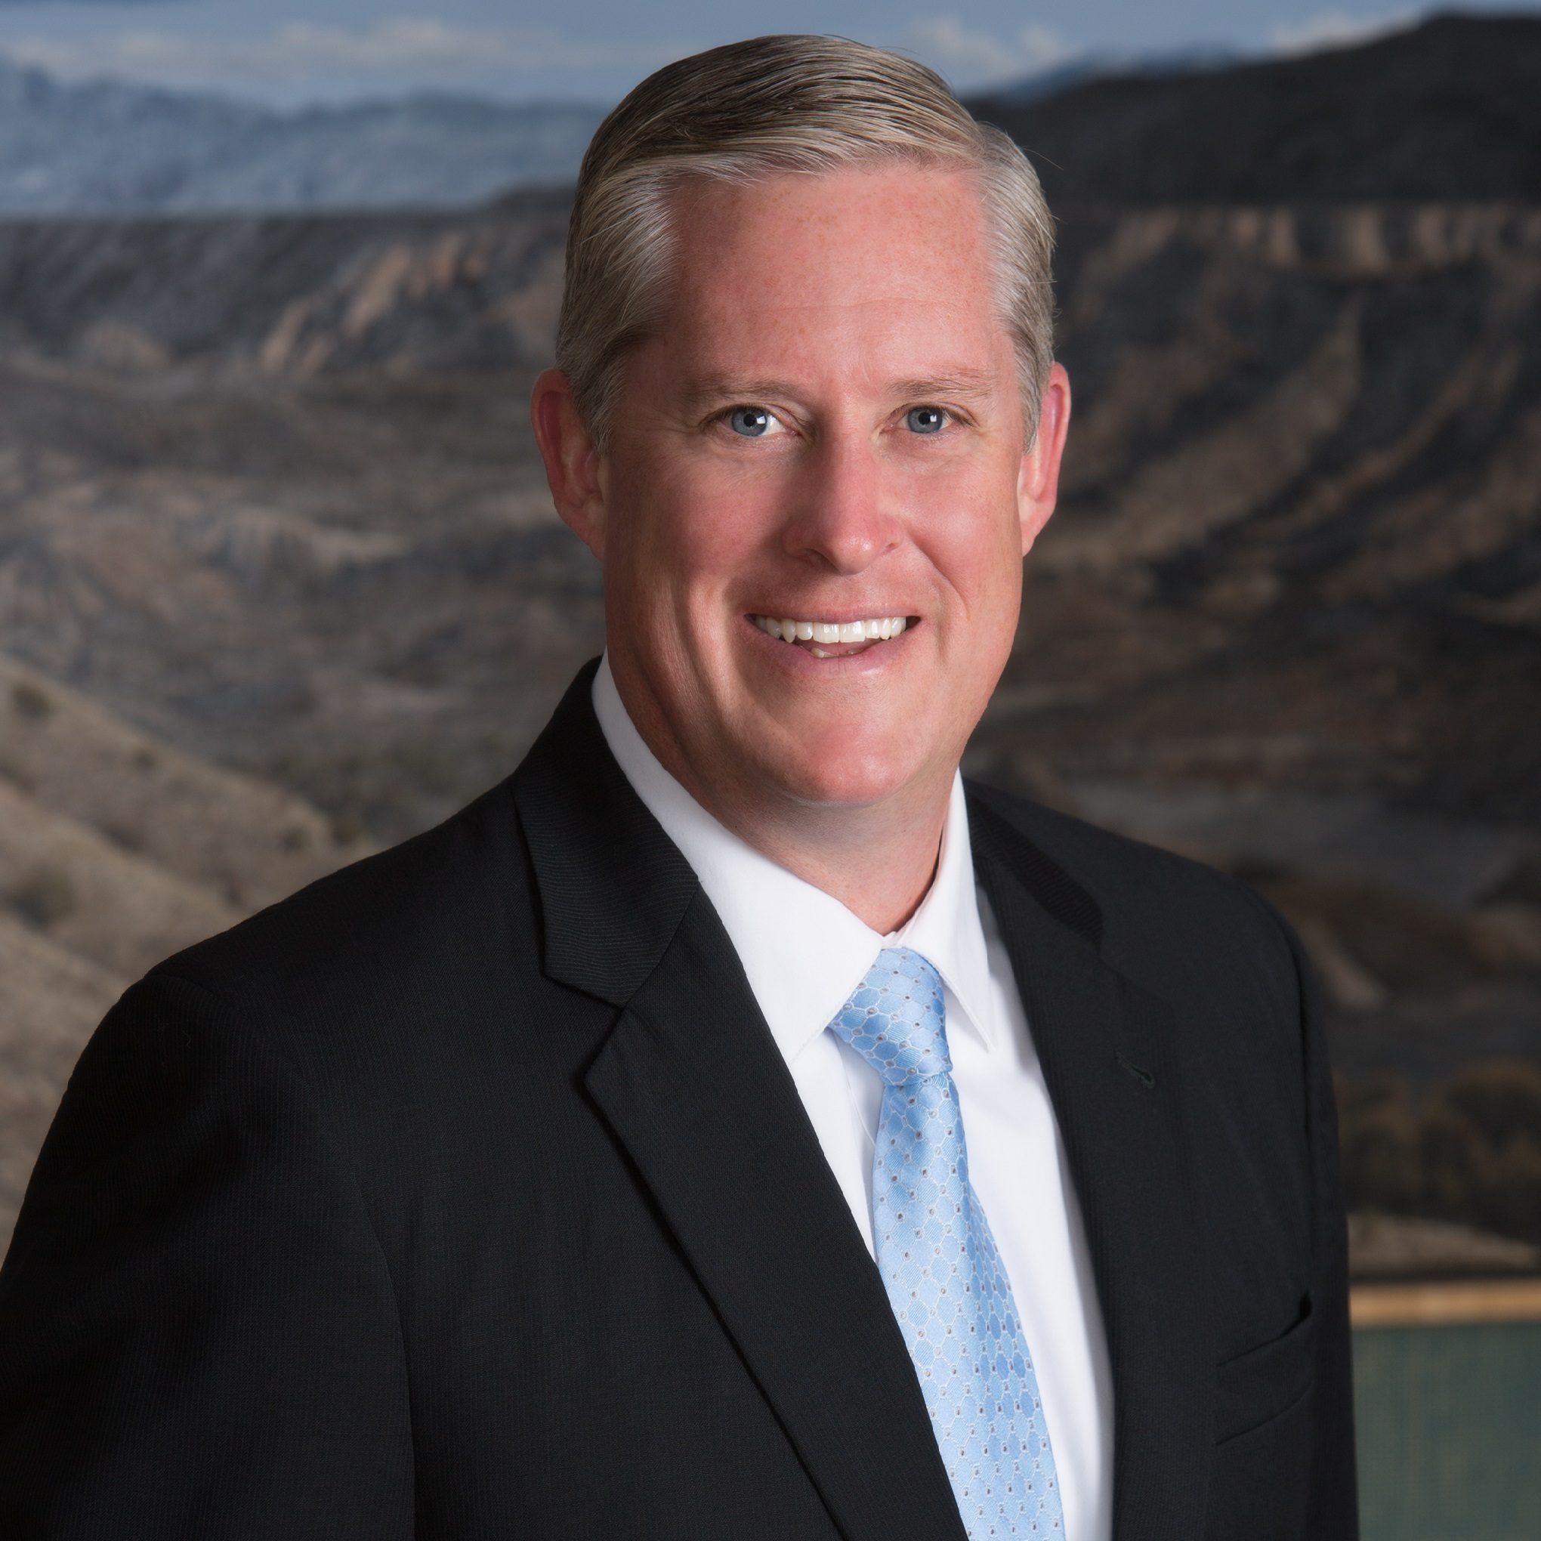  Timothy McKay, CPA  Incoming Independent Member Advisory Council Chair  Harris Finley & Bogle, PC  Fort Worth, TX  (817) 870-8763  tmckay@hfblaw.com | 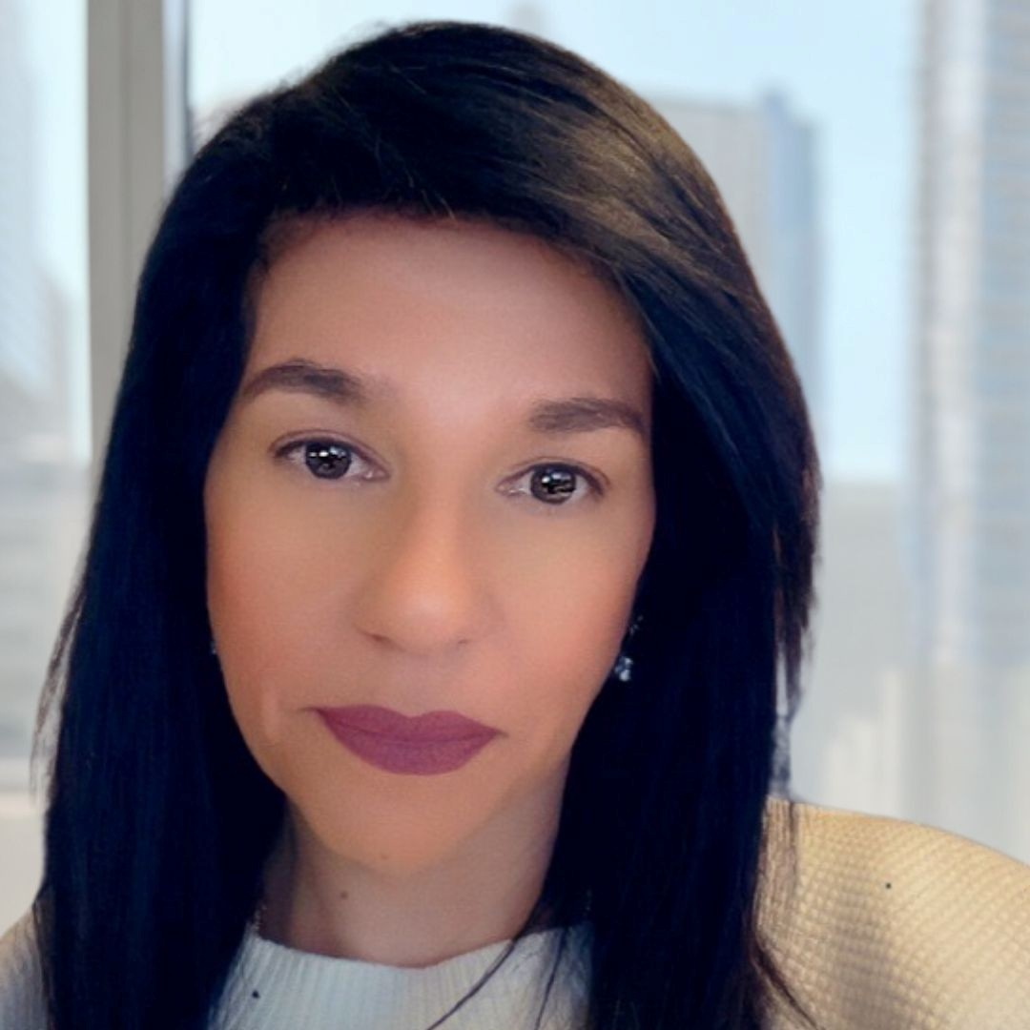  Sylvia Mankarious  Diversity, Equity, Inclusion and Accessibilitiy Advisory Council Chair  Mueting Raasch Group  Minneapolis, MN  612-767-5001  smankarious@mrgiplaw.com
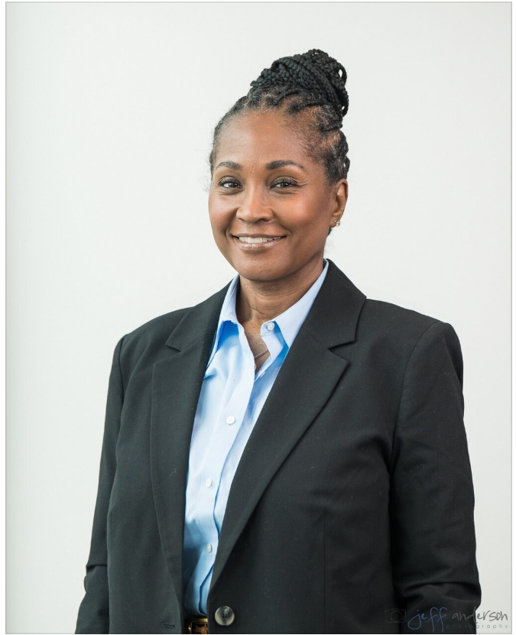  Lisa D. Moore  Incoming Diversity, Equity, Inclusion and Accessibility Advisory Council Chair  Maron Marvel Bradley Anderson & Tardy, LLC  Wilmington, DE  302-472-1732  LMoore@maronmarvel.com | 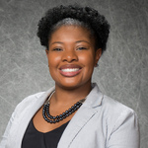  Terri D. Moore-Natal, SPHR  Director  Holzer Patel Drennan  Denver, CO  (720) 204-5732  tmoorenatal@hpdlaw.com
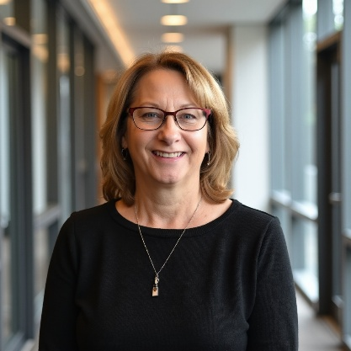  Terri J. Oppelt, CLM, SPHR, SHRM-SCP  CLM Certification Question Writing Committee Chair  Johnson Shapiro Slewett & Kole LLP  West Hollywood, CA  424-451-4212  Terri@jssk.com | 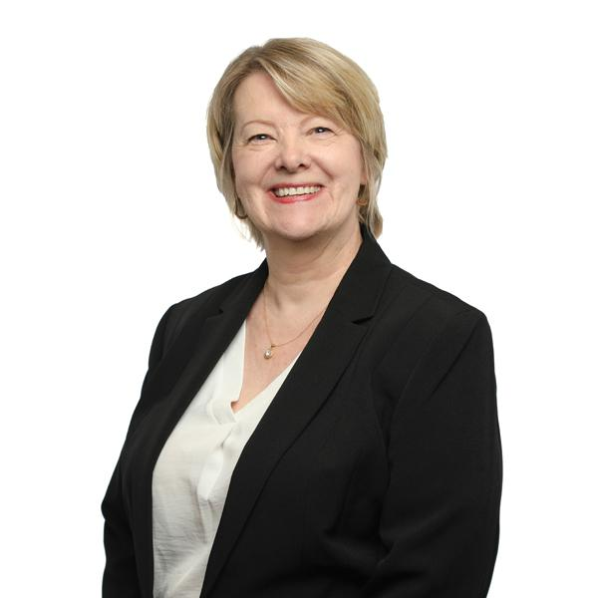  Mary Ann Rojas, CLM, SPHR, SHRM-SCP  Incoming CLM Promotion Committee Chair  Goldberg Kohn Ltd  Chicago, IL  (312) 201-3961  maryann.rojas@goldbergkohn.com
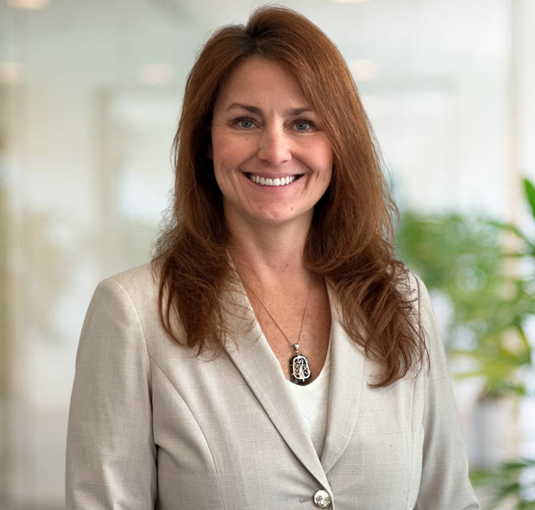  Kelli Taylor Sanders, CLM, MSLA  Director  Barnwell Whaley Patterson & Helms  Charleston, SC  843-577-7700  ksanders@barnwell-whaley.com | 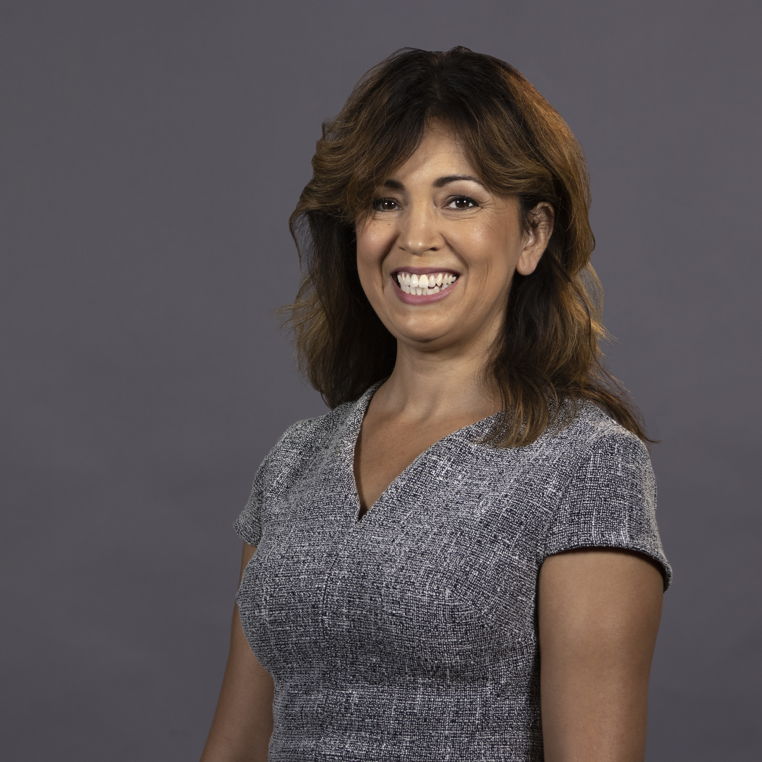  Laila M. Sanousi, CLM  Director-Elect  Peebles Bergin Schulte & Robinson LLP  Sacramento, CA  (916) 441-2700  lsanousi@ndnlaw.com
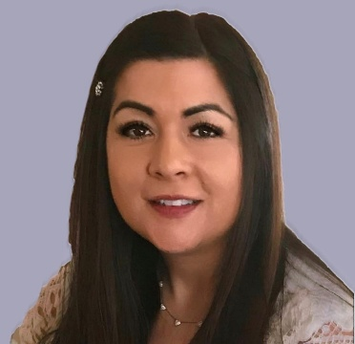  Veronica Spongberg, MBA,SHRM-CP,CCWS  Incoming Member Experience Committee Chair  Davis Wright Tremaine LLP  Los Angeles, CA  213-633-6875  veronicaspongberg@dwt.com  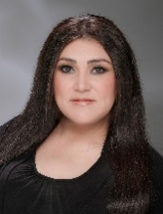  Carrie Valenzuela, MBA  Director  Meagher & Geer, PLLP  Scottsdale, AZ  480-624-8582  cvalenzuela@meagher.com  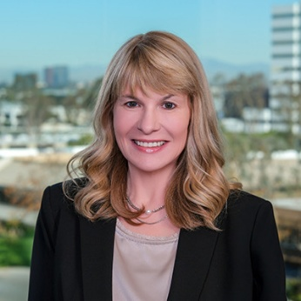  Lisa A. Waligorski, CLM, PHRca, SPHR  Director  Newmeyer & Dillion, LLP  Newport Beach, CA  949-271-7133  lisa.waligorski@ndlf.com | 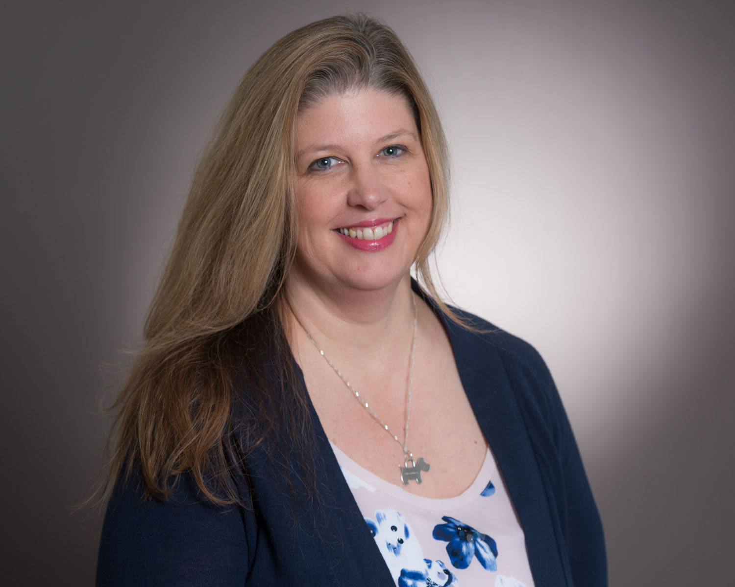  Shelley A. Strong – unable to attend  Incoming Volunteer Development and Experience Advisory Council Vice Chair  Littler Mendelson P.C.  San Jose, CA  (408) 795-3411  shstrong@littler.com  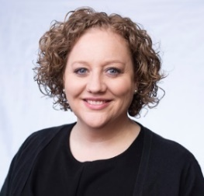  Jessica L. VanTroost  Director  Jacksonville, FL  904-224-4473  jessicavantroost12@gmail.com  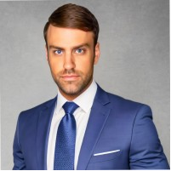  Laurence Winters  Incoming Future Readiness Advisory Council Chair  4L Managed Accounting LLC  Tampa, FL  513-401-4083  lwinters@4l-law.com
View ALA Headquarters Staff at this link.

