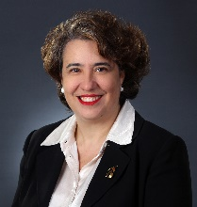  Angelina Angelov, CLM, MBA  Director  Russin Vecchi & Heredia Bonetti  Santo Domingo, DN  Dominican Republic  809-535-9511  aangelov@rvhb.com | 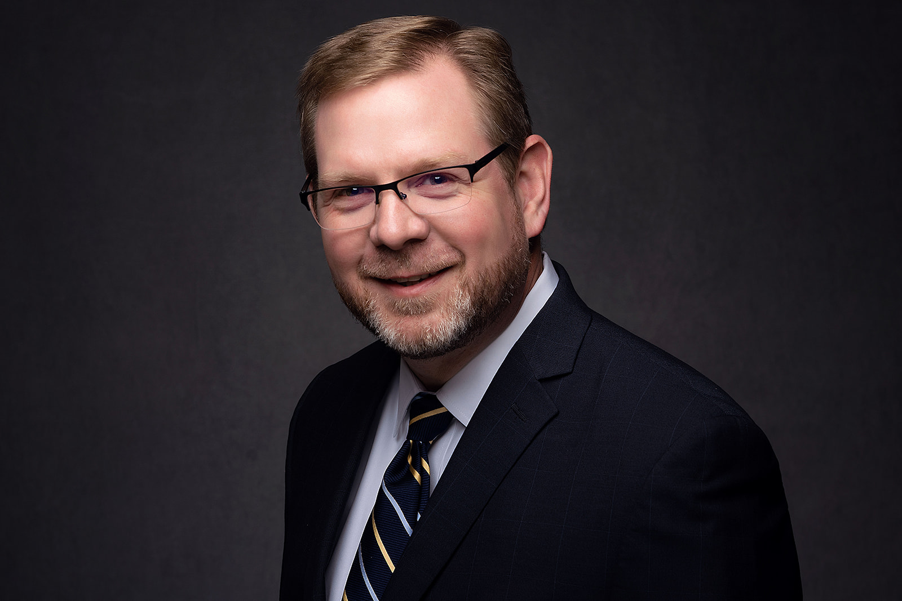  Travis C. Armstrong, CLM, CPA  President Elect  English Lucas Priest & Owsley, LLP  Bowling Green, KY  270-781-6500  tarmstrong@elpolaw.com
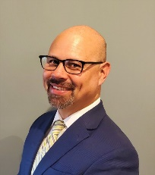  Daniel P. Atcheson  Director  Raleigh, North Carolina  252-229-7644  dpatcheson@yahoo.com | 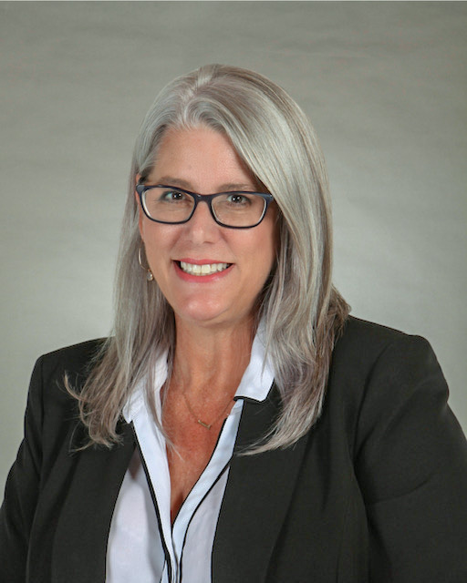  Elizabeth Bell  Incoming Independent Member Advisory Council Chair  DeFur Voran, LLP  Muncie, IN  (765) 288-3651  ebell@defur.com
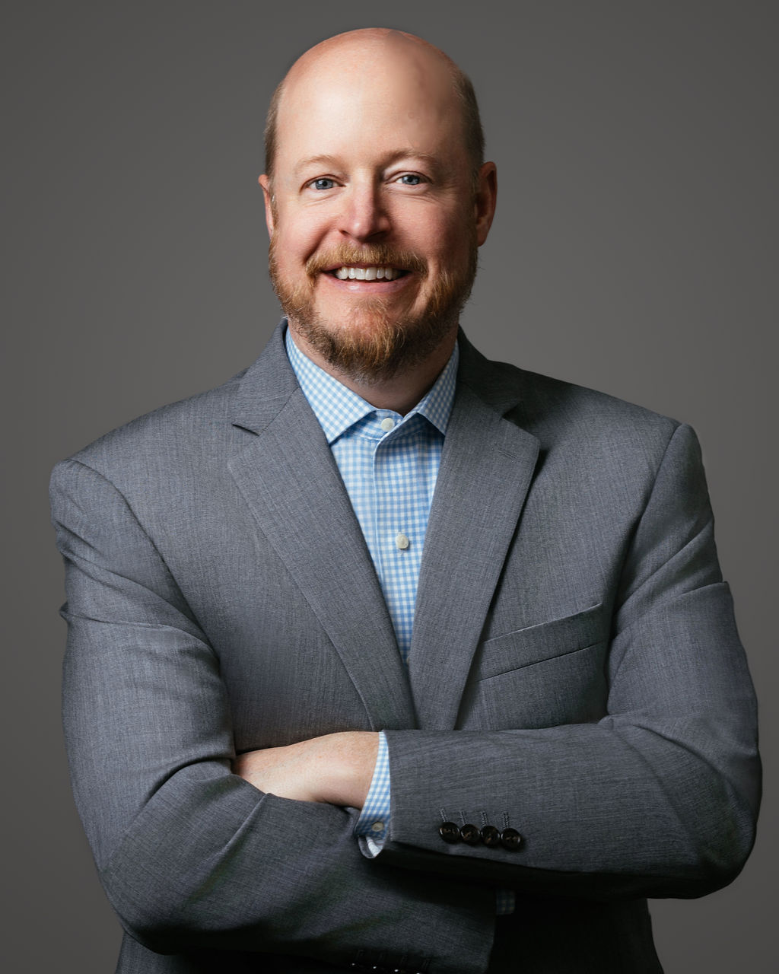  John D. Bowers  Incoming Future Readiness Advisory Council Chair  Thompson Burton PLLC  Nashville, TN  (615) 465-6000  john.bowers@thompsonburton.com | 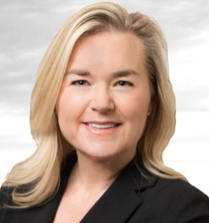  Katie J. Bryant, CLM  Incoming CLM Certification Promotion Project Team Chair  Udall Shumway PLC  Mesa, AZ  (480) 461-5345  kjb@udallshumway.com
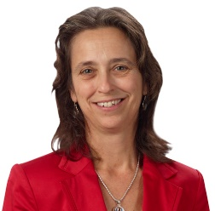  Linda Copson  Incoming CLM Certification Question Writing Committee Vice Chair  Downs Rachlin Martin, PLLC  St. Johnsbury, VT  802-473-4205  Lcopson@drm.com | 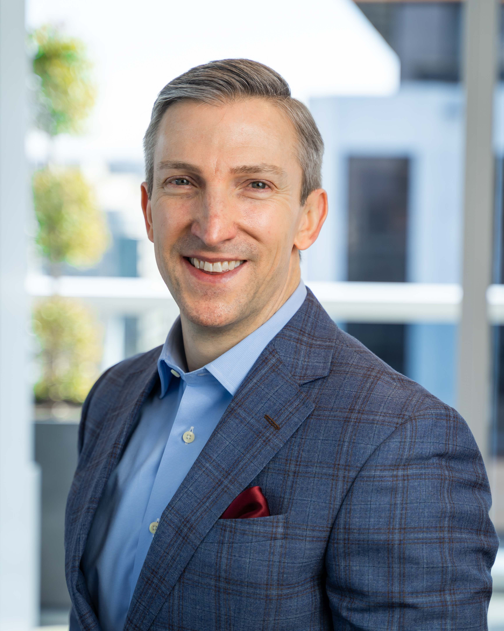  James L. Cornell III  LegaLeaders: ALA’s Executive Leadership Summit Project Team Chair  Shook, Hardy & Bacon L.L.P.  Irvine, CA  (202) 210-5321  jcornell@shb.com
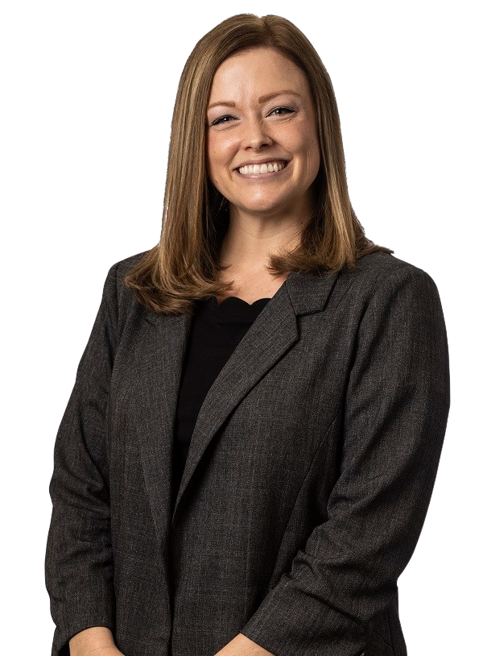  Sarah E. Cramer  Director  Baker Sterchi Cowden & Rice, L.L.C.  Kansas City, MO  (816) 448-9370  scramer@bakersterchi.com | 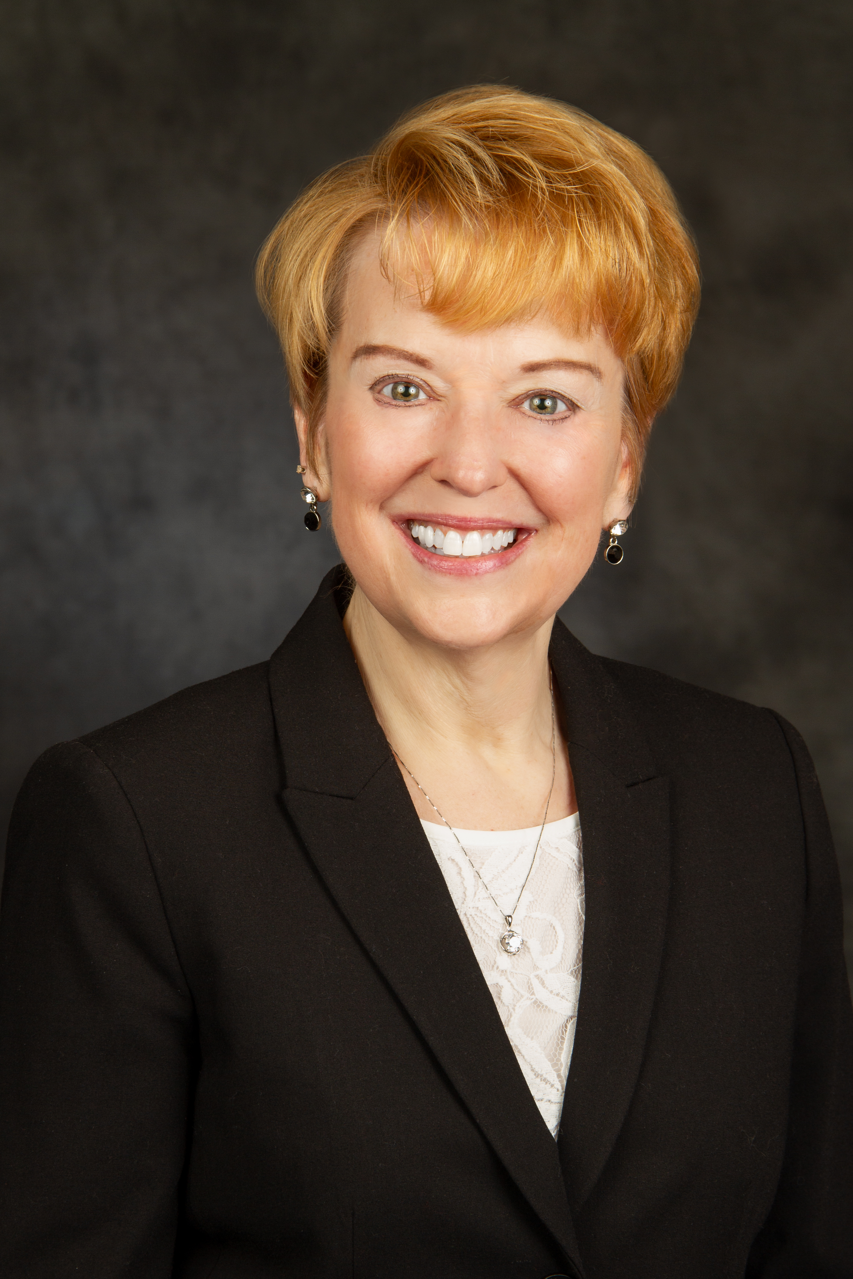  Brenda S. Deertz, MBA  Incoming Member Experience Committee Chair  Bi-State Development Agency  St. Louis, MO  314-982-1588  bsdeertz@bistatedev.org
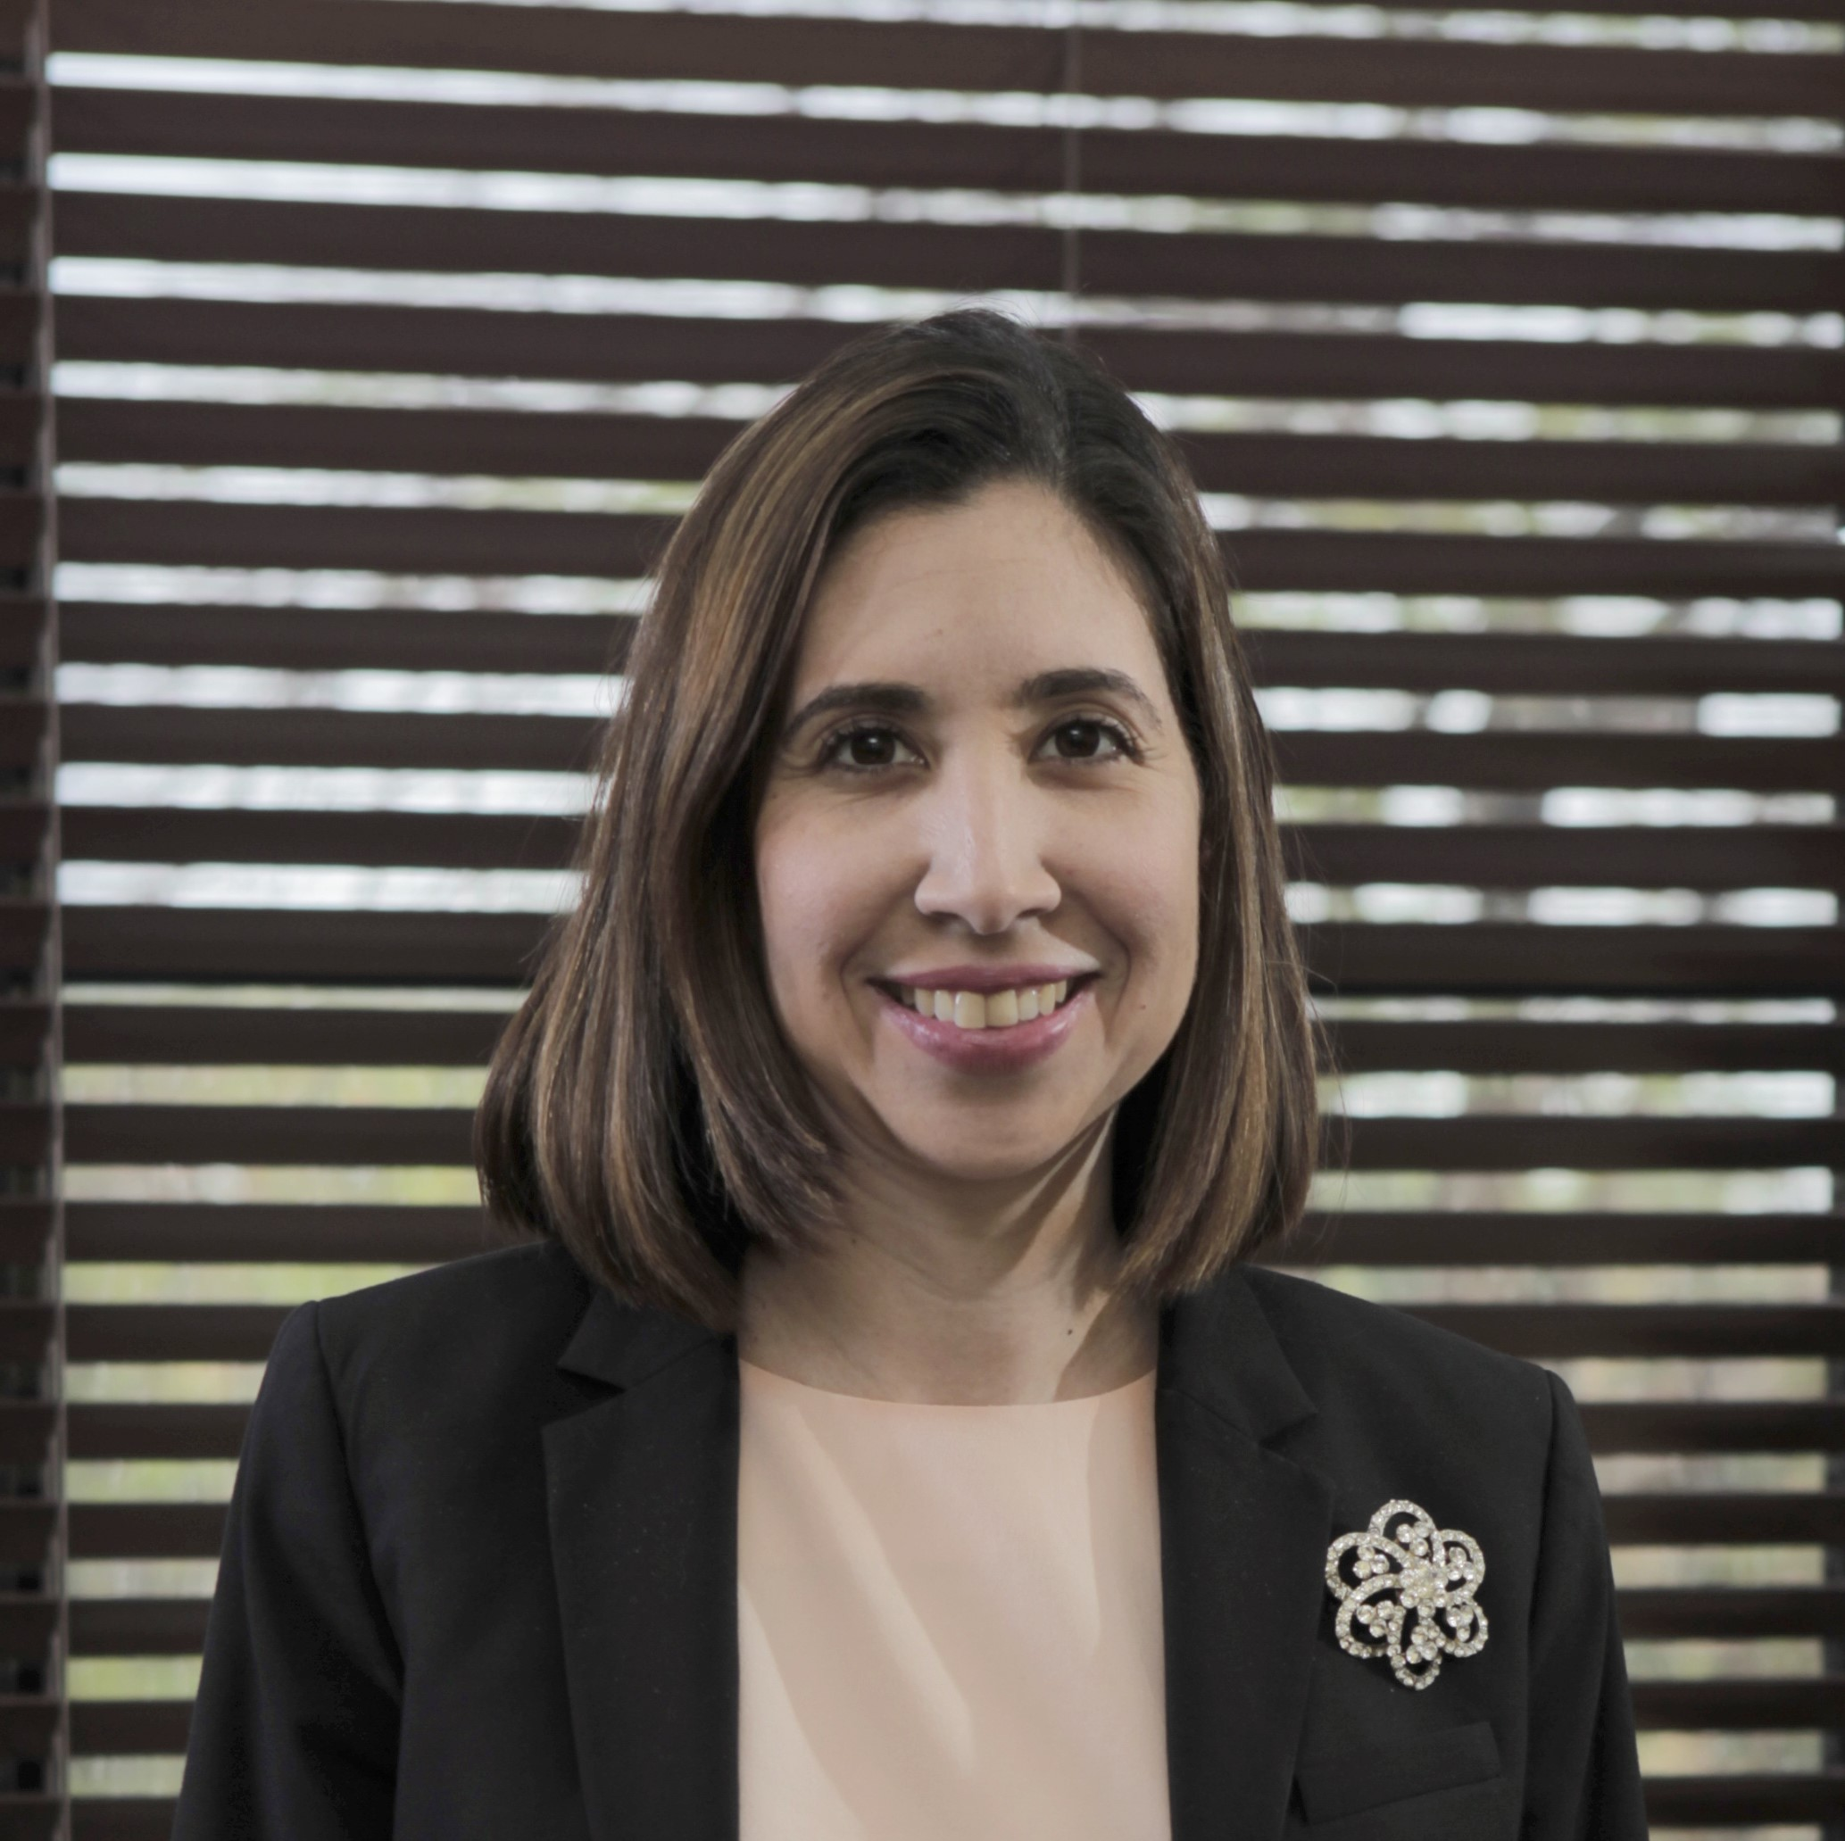  Mónika Fiallo  ALA's Legal Collective Project Team Chair  Russin Vecchi & Heredia Bonetti  Santo Domingo, Dominican Republic  18095359511  mfiallo@rvhb.com | 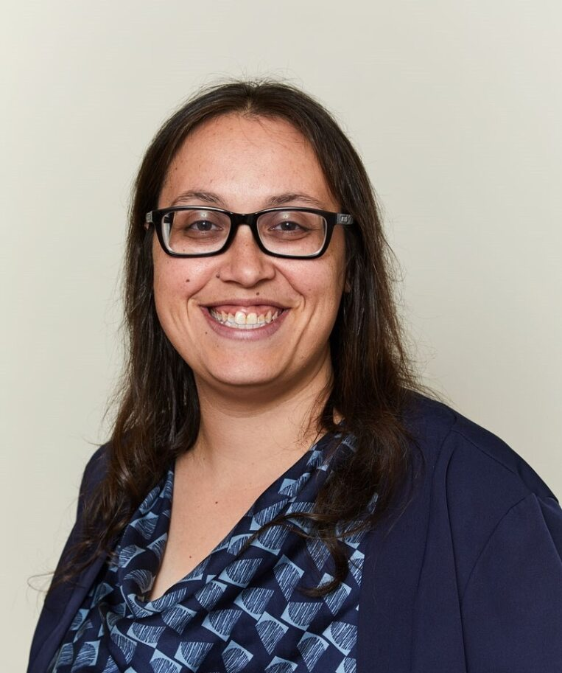  Elyssa A. Goldstein, CLM, PHR, SHRM-CP  Director  Rebenack Aronow & Mascolo, LLP  New Brunswick, NJ  732-247-3600  egoldstein@ram.law
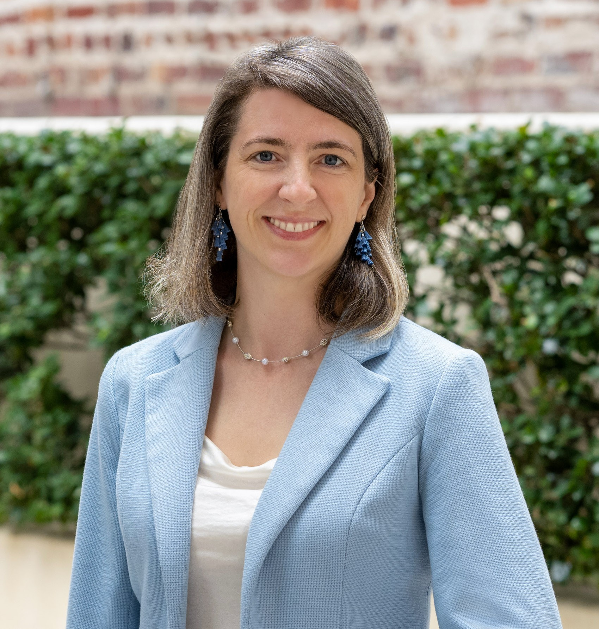  Kira L. Hansen, CLM  Foundation Vice President  Rosen Bien Galvan & Grunfeld, LLP  San Francisco, CA  (415) 433-6830  khansen@rbgg.com | 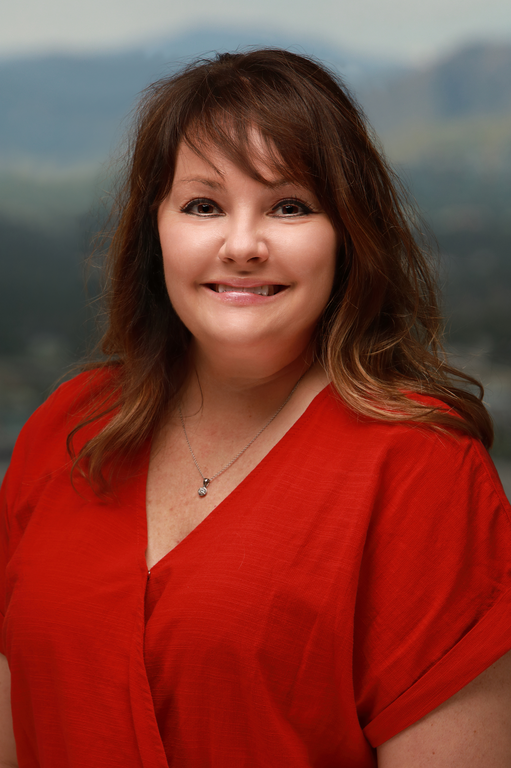  Stacie Hedrick, CLM  Incoming Chapter Connection Committee Chair  Welborn Sullivan Meck & Tooley, PC  Denver, CO  (303) 830-2500  shedrick@wsmtlaw.com
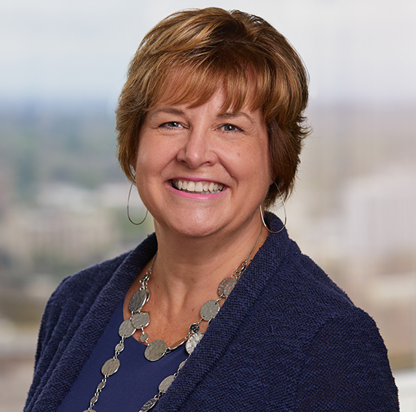  Lori A. Hughes – unable to attend  Incoming Member Ambassador Committee Chair  Miller Nash LLP  Portland, OR  (503) 205-2310  lori.hughes@millernash.com |   Rose A. Jaworecki  Incoming Director  Thompson Hine, LLP  New York, NY  212-908-3989  Rose.jaworecki@thompsonhine.com
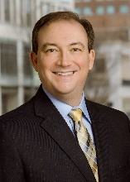 | 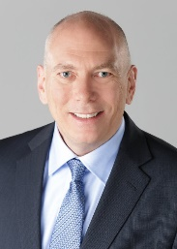
Michael E. Keatts – unable to attend  Incoming Chapter Connection Committee Vice Chair  Bowman and Brooke LLP  Richmond, VA  804-819-1135  michael.keatts@bowmanandbrooke.com | Ken Koehn, CLM, CPA, CMA  Director  Gould & Ratner LLP  Chicago, IL  312-899-1620  Kkoehn@gouldratner.com
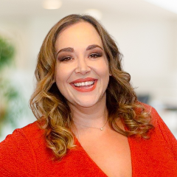  Amanda R. Koplos, CLM, CPA  President  Shuffield Lowman & Wilson, PA  Orlando, FL  (407) 581-9800  akoplos@shuffieldlowman.com | 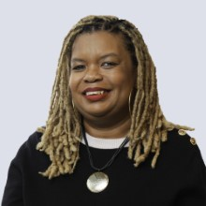  Tiffany Diane McLean – unable to attend  Incoming Member Ambassador Committee Vice Chair  Warner Norcross + Judd LLP  Detroit, MI  313-546-6048  tmclean@wnj.com
  Jerry G. McPeake, MSLA  Director  Minor & Brown PC  Denver, CO  303-376-6004  jmcpeake@mb-law.law | No photo submitted  Sylvia Mankarious  Incoming Diversity, Equity, Inclusion and Accessibilitiy Advisory Council Chair  Mueting Raasch Group  Minneapolis, MN  612-767-5001  smankarious@mrgiplaw.com
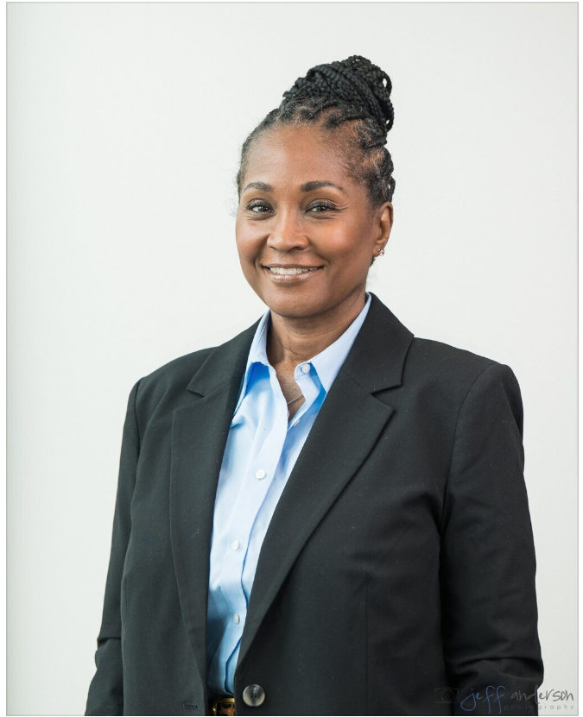  Lisa D. Moore  Incoming Diversity, Equity, Inclusion and Accessibility Advisory Council Vice Chair  Maron Marvel Bradley Anderson & Tardy, LLC  Wilmington, DE  302-472-1732  LMoore@maronmarvel.com | 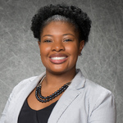  Terri D. Moore-Natal, SPHR  Director  Holzer Patel Drennan  Denver, CO  (720) 204-5732  tmoorenatal@hpdlaw.com
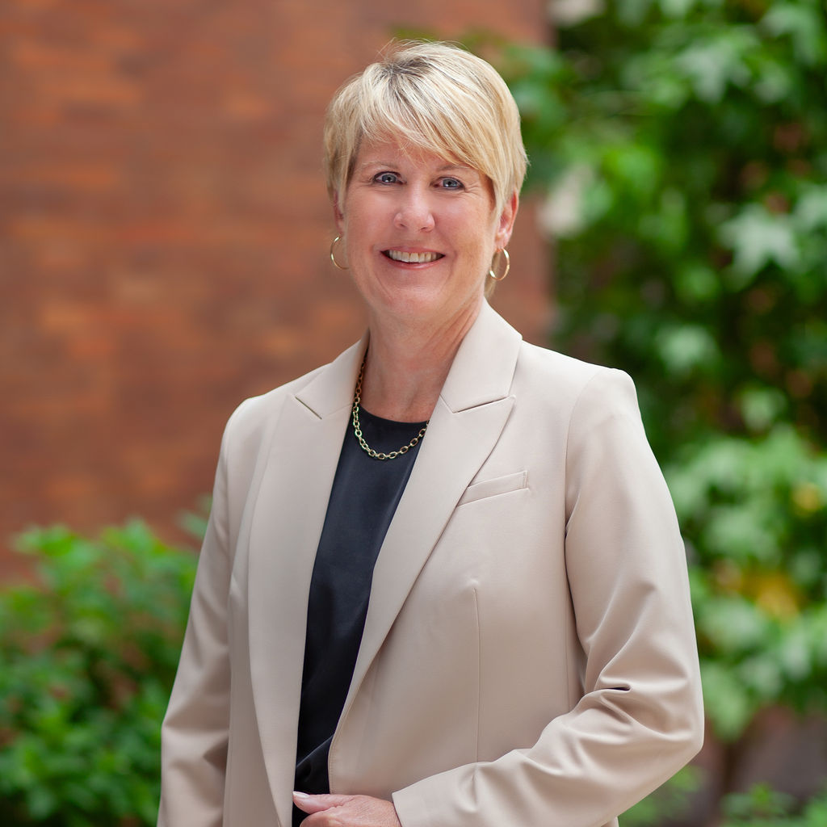  Andrea L. Myers, CLM  2026 Annual Conference & Expo Project Team Chair  Rhoades McKee PC  Grand Rapids, MI  616-233-5102  amyers@rhoadesmckee.com | 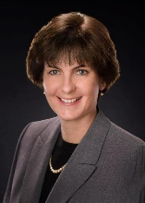  Clara E. Onderdonk, CLM  Director  Ernstrom & Dreste, LLP  Rochester, NY  585-473-3100  conderdonk@ed-llp.com
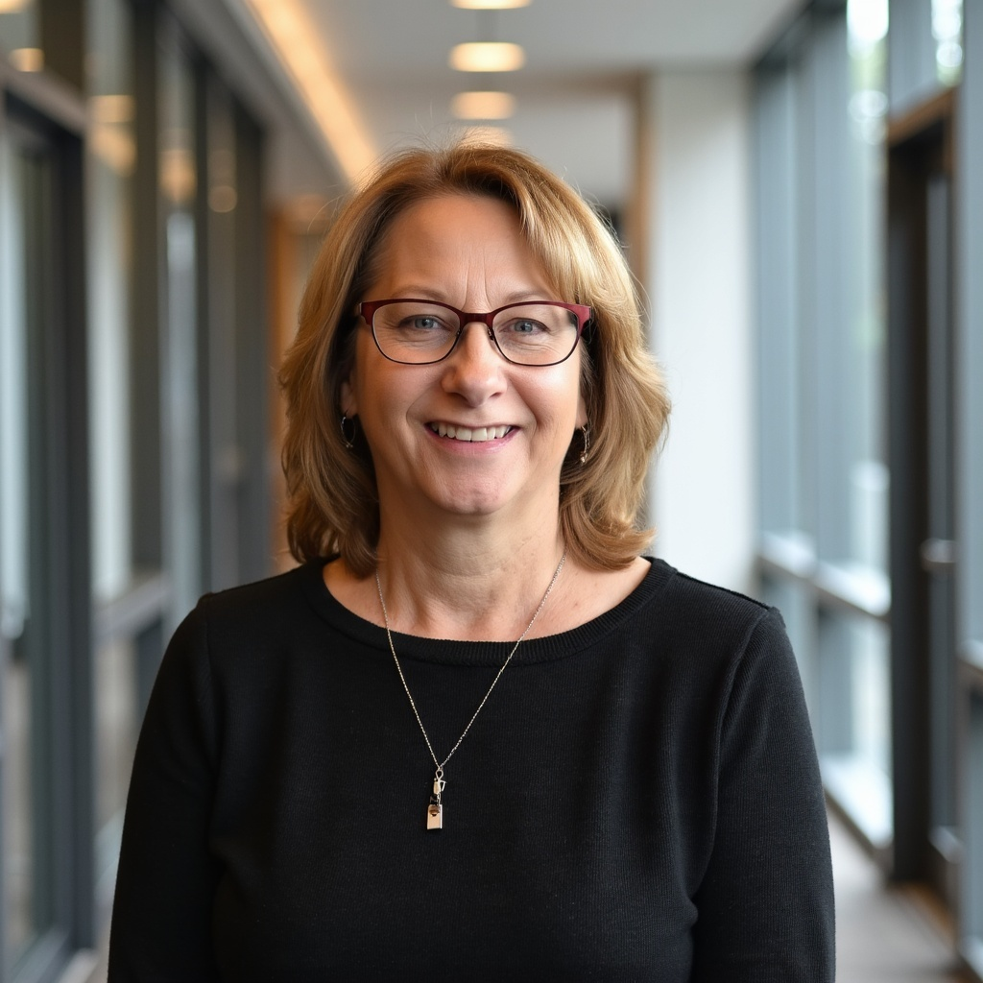  Terri J. Oppelt, CLM, SPHR, SHRM-SCP  Incoming CLM Certification Question Writing Committee Chair  Johnson Shapiro Slewett & Kole LLP  West Hollywood, CA  424-451-4212  Terri@jssk.com | 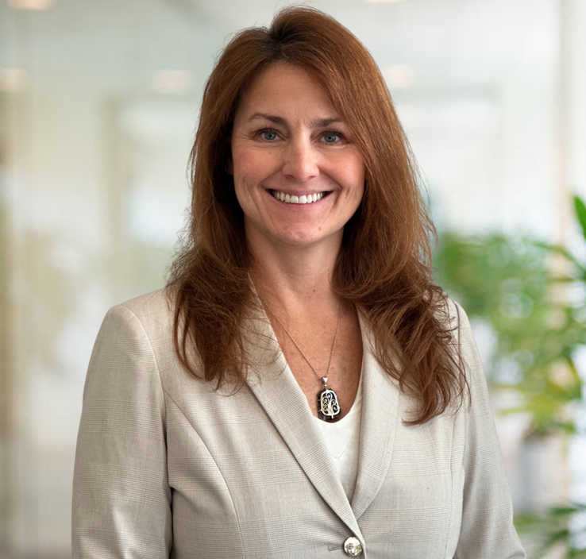  Kelli Taylor Sanders, CLM, MSLA  Incoming Director  Barnwell Whaley Patterson & Helms  Charleston, SC  843-577-7700  ksanders@barnwell-whaley.com
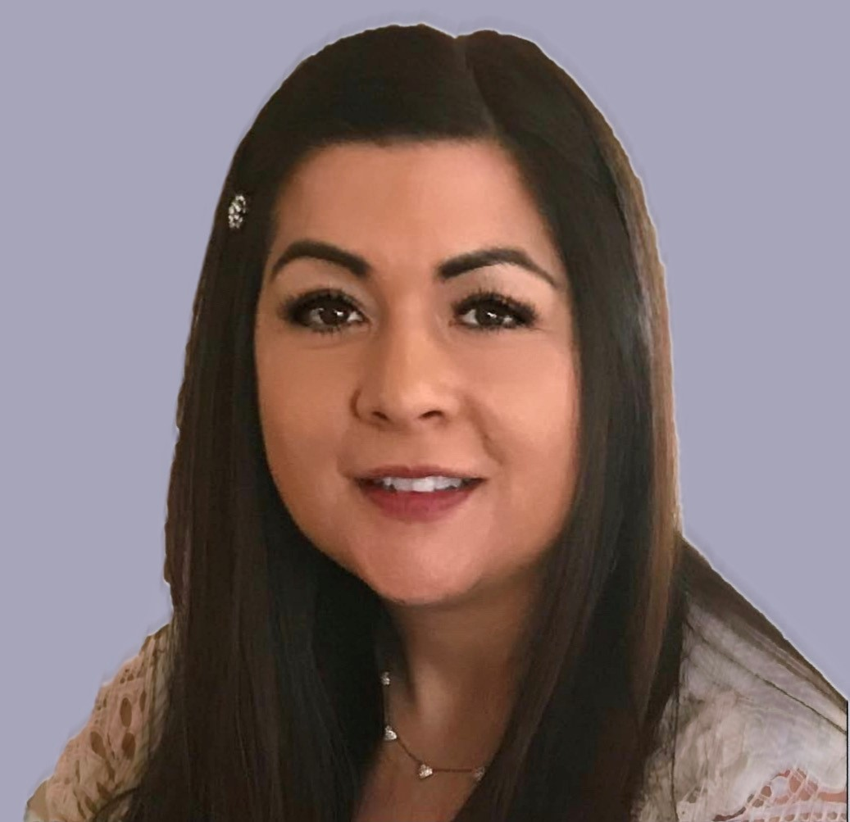  Veronica Spongberg, MBA,SHRM-CP,CCWS  Incoming Member Experience Committee Vice Chair  Davis Wright Tremaine LLP  Los Angeles, CA  213-633-6875  veronicaspongberg@dwt.com | 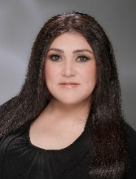  Carrie Valenzuela, MBA  Incoming Director  Meagher & Geer, PLLP  Scottsdale, AZ  480-624-8582  cvalenzuela@meagher.com
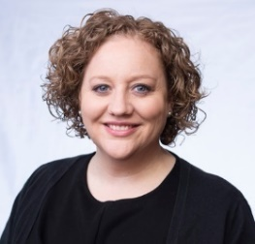  Jessica L. VanTroost  Director  McGlinchey Stafford, PLLC  Jacksonville, FL  904-224-4473  Jvantroost@mcglinchey.com | 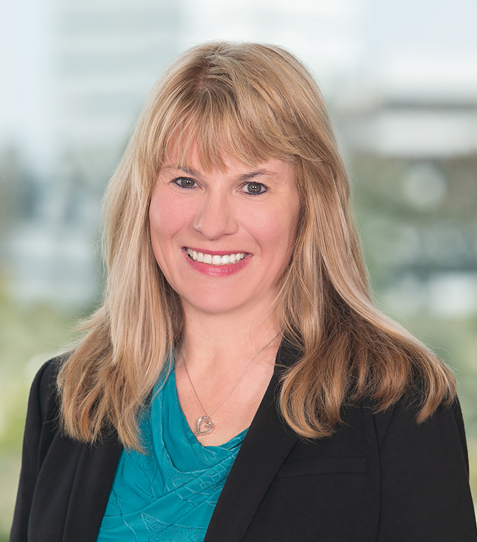  Lisa A. Waligorski, CLM, PHRca, SPHR  Incoming Director – unable to attend  Newmeyer & Dillion, LLP  Newport Beach, CA  949-271-7133  lisa.waligorski@ndlf.com
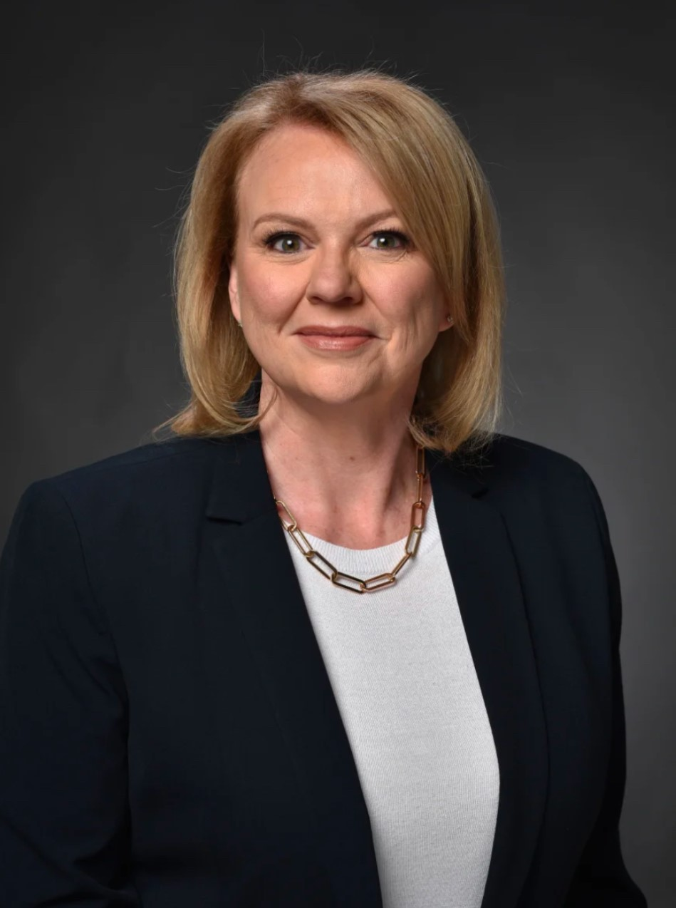  Jane M. West, CLM, SPHR, SHRM-SCP  Level Up: Legal Management Fundamentals Project Team Chair  Vedder Price  Dallas, TX  469-895-4735  jwest@vedderprice.com | 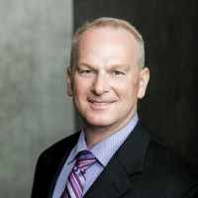  Geoffrey M. Williams, CLM, MBA, M.Div.  Immediate Past President  Stone Pigman Walther Wittmann L.L.C.  New Orleans, LA  504-593-0940  Gwilliams@stonepigman.com
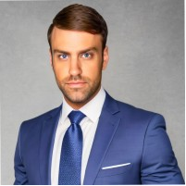  Laurence Winters  Incoming Future Readiness Advisory Council Vice Chair  Cincinnati, OH  513-401-4083  laurence.winters23@gmail.com | View ALA headquarters staff roster here.

