UPBMS Branches

Branches represent the highest organizational level within the ALA UPBMS Codes. They are used to organize the substantive areas into two primary groupings that represent the two sides of a typical legal services operation.

Support Branch

The Support Branch is used to describe processes associated with professional assistance provided to lawyers directly related to the delivery of legal services, advice and counsel.

Classifications within this Branch:

Administrative Support (AS)
Finance (FN)
Human Resources (HR)
Business Development (BD)
Information Technology (IT)
Leadership and Management (LM)

Legal Branch
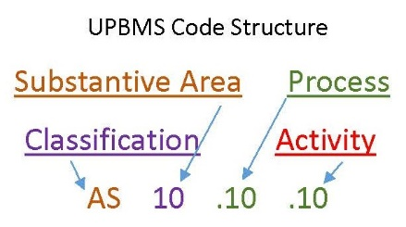
The Legal Branch is used to describe processes associated with professional assistance provided to lawyers directly related to the delivery of legal services, advice and counsel.

Classifications within this Branch:

Litigation (LT)
Transaction/M&A (Project) (TN)
Patent (PT)
Trademark (TM)
Workers’ Compensation (WC)
Bankruptcy (BK)
Other (Counseling) (CN)
Lobbying (Government Relations) (LB)

Questions?

For further information about the ALA UPBMS or the public comment process, please contact: alaupbms@alanet.org.

